|  |
| --- |
| Mclellan studios |
| PyDefense |
| **Awesome tower defense game!** |
| Version #4  All work Copyright © 2012 by McLellan Studios.  All rights reserved. |
| **Brandon McLellan** |
|  |



|  |
| --- |
| May 16th 2012 |

**Table of Contents**

1. Version History
2. Game Overview
3. Game Play Mechanics
4. Controls
5. Interface Sketch
6. Menu and Screen Description
7. Game World
8. Enemies
9. Scoring
10. Sound Index
11. Art / Multimedia Index

**Version History**

**Version 3**

* Added Very Hard difficulty and splash screen.

**Version 2**

* Finished game overview, mechanics and added controls and interface sketch.
* Added everything into Table of Contents.

**Version 1**

* Edited title page with relevant company and game information.
* Began writing game overview and mechanics.

1. **Game Overview**

The objective of the game is to strategically place cannons to kill the endless waves of monsters.

1. **Game Play Mechanics**

*The player places cannons on a 20x14 grid, which the monsters then attempt to travel across. The player can upgrade cannons and use them to make the monsters follow a specific path. The monsters vary and get progressively harder as the game continues. There is four difficulties (Easy, Normal, Hard and Very Hard) the player can choose from.*

1. **Controls**

The game is controlled completely using the mouse.

1. **Interface Sketch**

Splash Screen

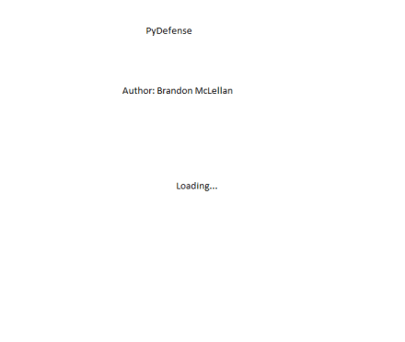

*Main Screen*

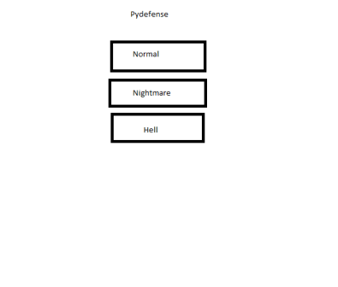

*Game Screen*

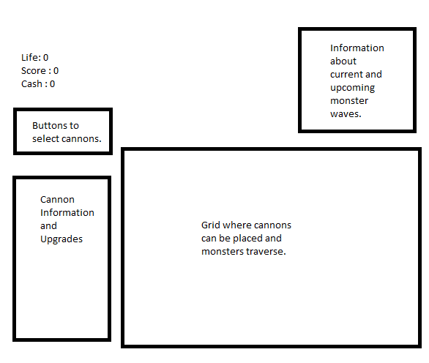

*End Screen*

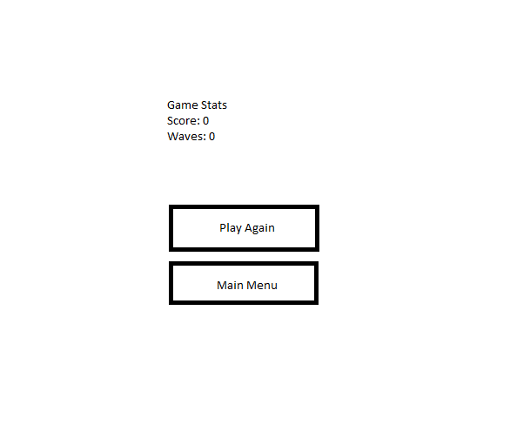

1. **Menu and Screen Descriptions**

Splash Screen

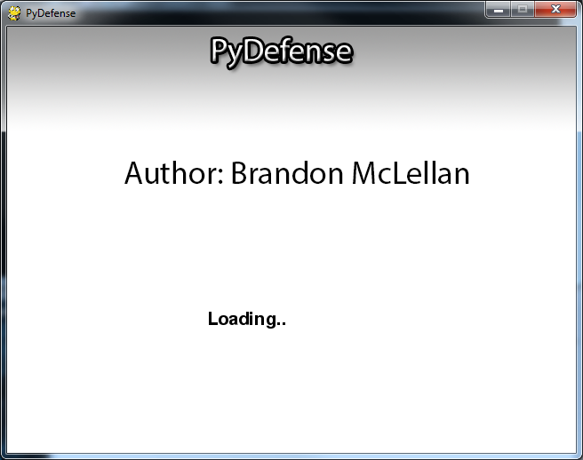

Main Screen

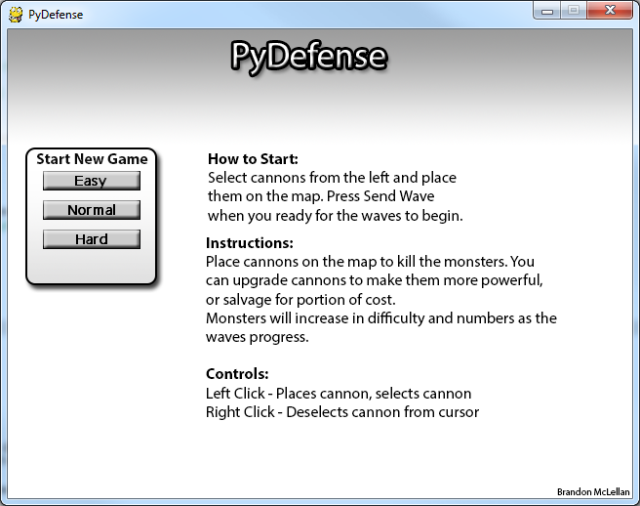

Game Screen

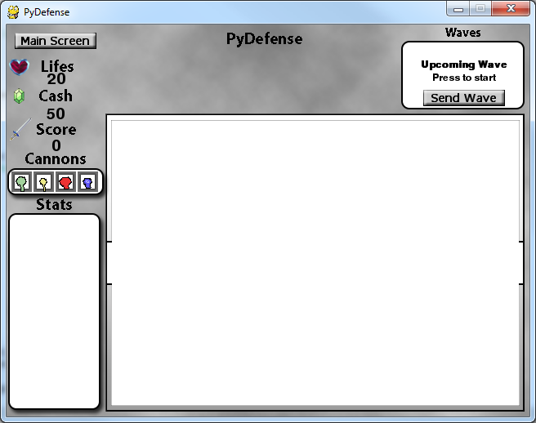

End Screen

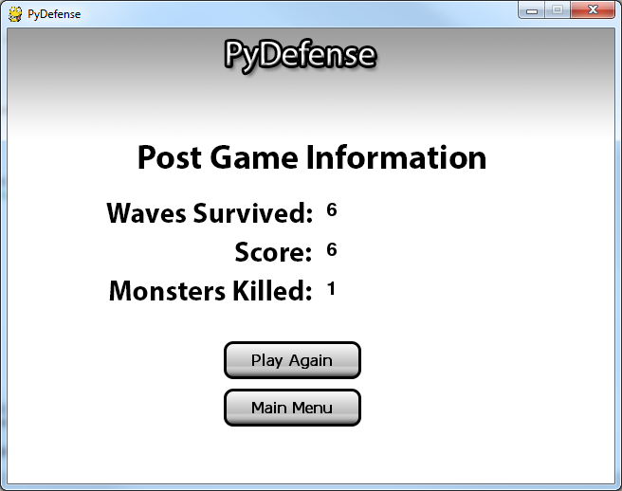

1. **Game World**

*The game world is a 20x14 grid which cannons can be placed on. The monsters traverse the grid following a path around the cannons.*

1. **Enemies**

There is four types of enemies: Normal, Fast, Immune and Boss. Each have varying stats (Health, Speed, Score for killing, Cash for killing), that progressively go up as you play. They follow a generated path to the exit point, avoiding the cannons.

1. **Scoring**

The player gets points for every monster they kill, the amount of points depends on the difficulty of the monster.

1. **Sound Index**

|  |  |  |
| --- | --- | --- |
| Sound File | Duration | Use |
| Lifeloss.wav | **00:00:01** | **Played when monster gets to end and you lose a life.** |
| Newwave.wav | **00:00:02** | **Plays when a new wave enters the map** |
| Shoot.wav | **00:00:01** | **Plays when a cannon shoots at a monster.** |
| Soundtrack.ogg | **04:26:57** | **Background music** |
|  |  |  |

1. **Art / Multimedia Index**

|  |  |  |
| --- | --- | --- |
| Picture | Filename | Use |
| D:\Users\Brandon\workspace\PyDefense\assets\basic.png | **Basic.png** | **Basic cannon turret, rotates unless aiming at monster.** |
| D:\Users\Brandon\workspace\PyDefense\assets\sniper.png | **Sniper.png** | **Sniper cannon turret, rotates unless aiming at monster.** |
| D:\Users\Brandon\workspace\PyDefense\assets\freeze.png | **Freeze.png** | **Freeze cannon turret, rotates unless aiming at monster.** |
| D:\Users\Brandon\workspace\PyDefense\assets\splash.png | **Splash.png** | **Splash cannon turret, rotates unless aiming at monster.** |
| D:\Users\Brandon\workspace\PyDefense\assets\Cannon.png | **Border.png** | **Border that goes behind the cannon, used to show selection and hovering.** |
| D:\Users\Brandon\workspace\PyDefense\assets\normal.png | **Normal.png** | **Normal monster sprite** |
| D:\Users\Brandon\workspace\PyDefense\assets\fast.png | **Fast.png** | **Fast monster sprite** |
| D:\Users\Brandon\workspace\PyDefense\assets\immune.png | **Immune.png** | **Immune monster sprite** |
| D:\Users\Brandon\workspace\PyDefense\assets\boss.png | **Boss.png** | **Boss monster sprite** |
| D:\Users\Brandon\workspace\PyDefense\assets\missile.png | **Missile.png** | **Missile sprite, shoots from cannon at monster.** |
| D:\Users\Brandon\workspace\PyDefense\assets\SmallButton.png | **SmallButton.png** | **Button images used for normal, hovering and depress.** |
| D:\Users\Brandon\workspace\PyDefense\assets\MainScreen.png | **MainScreen.png** | **Background of the main screen, when the game first starts.** |
| D:\Users\Brandon\workspace\PyDefense\assets\GameScreen.png | **GameScreen.png** | **Background of the main game screen** |
| D:\Users\Brandon\workspace\PyDefense\assets\EndScreen.png | **EndScreen.png** | **Used for background of the end screen.** |
| D:\Users\Brandon\workspace\PyDefense\assets\SplashScreen.png | **SplashScreen.png** | **Used for background of the splash screen** |
|  | **MyriadPro.otf** | **Font used for all text in game** |